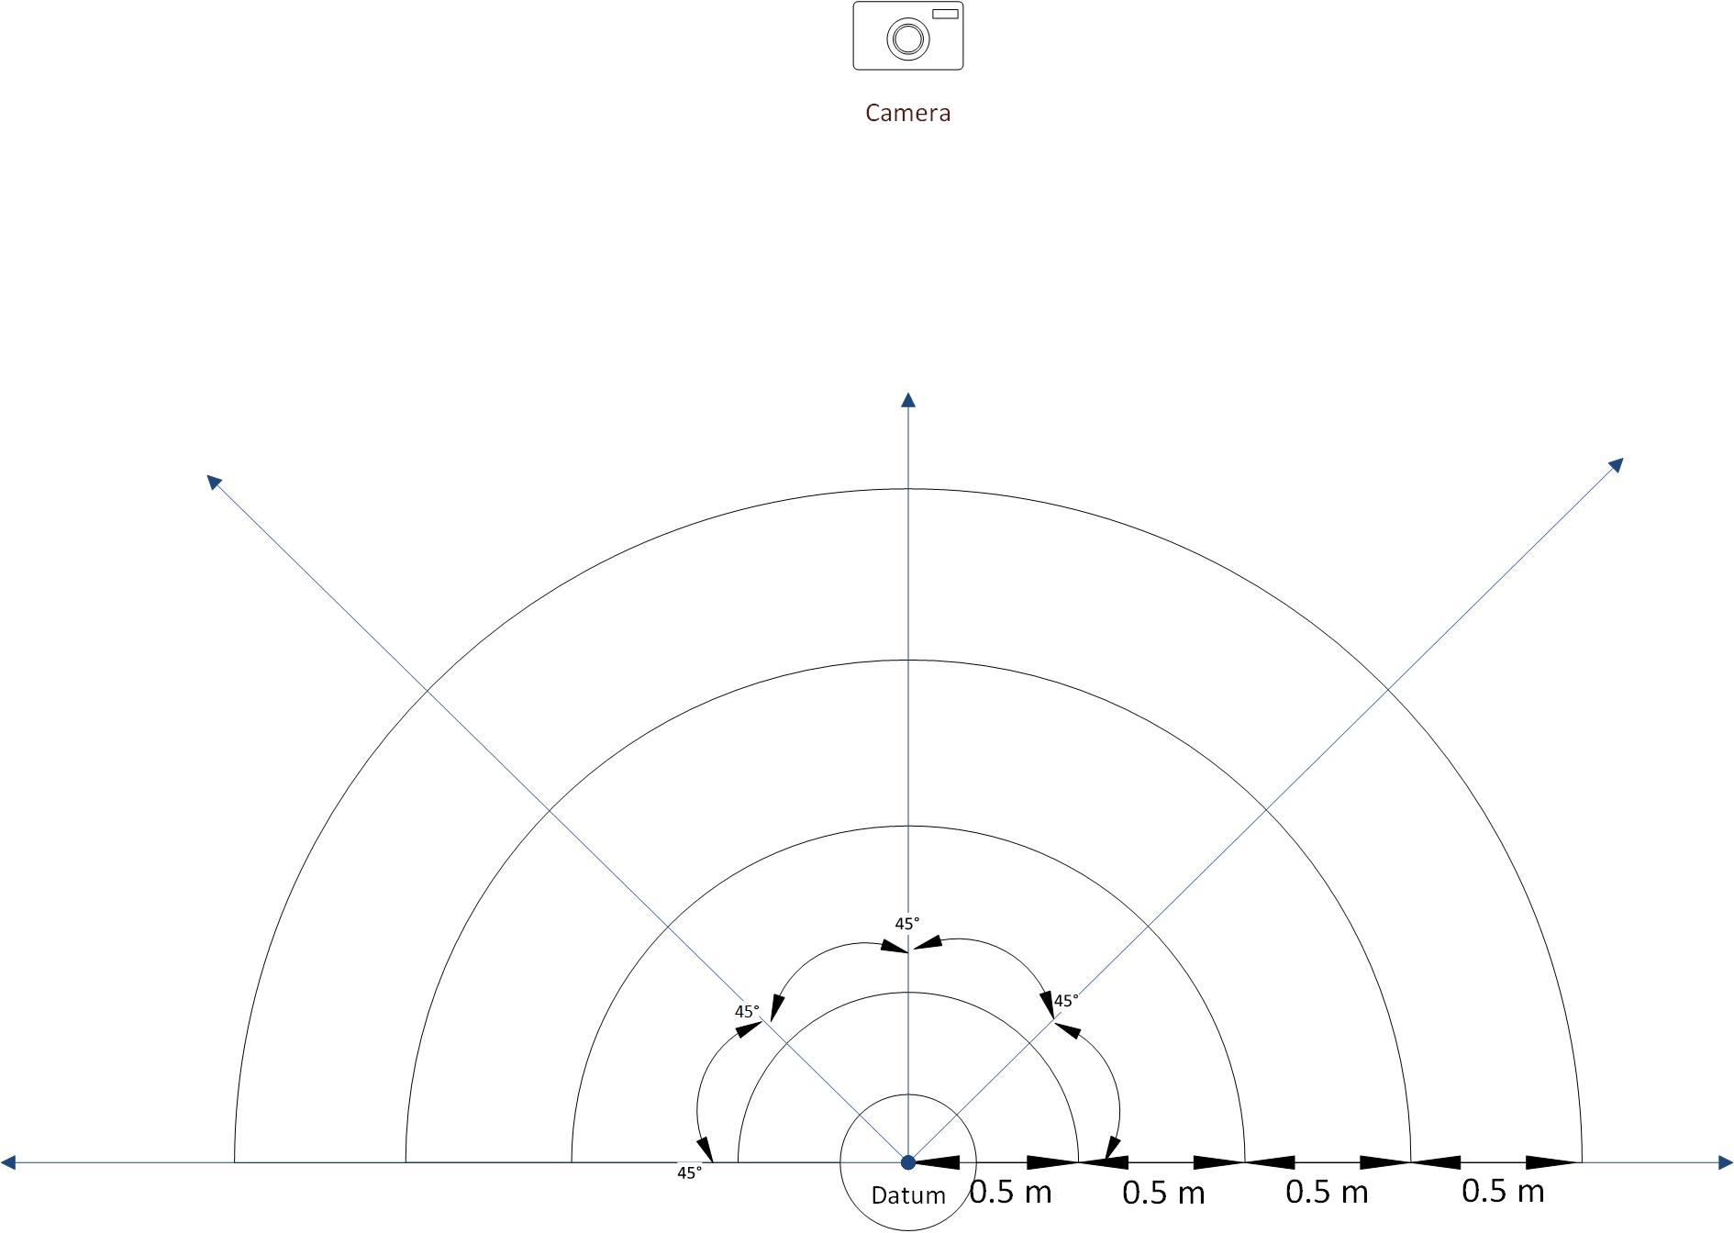

Figure1. Calibration Plan for Distance Between Human and Datum

**How to detect human speed?**

1. Speed gun (ask if anyone has one?)
2. [Android](https://play.google.com/store/apps/details?id=kr.sira.speed&hl=en_US) / ios app (may not be accurate)
3. Build a circuit with IR sensors ([exmaple](http://www.circuitstoday.com/car-speed-detector-arduino))
4. Use Velocity = Distance/Time and assume constant speed.

**The test of the server:**

We used Postman to send multiple requests to the server in a short time. The average responding time of the server is 7.3ms.